Last occurrence
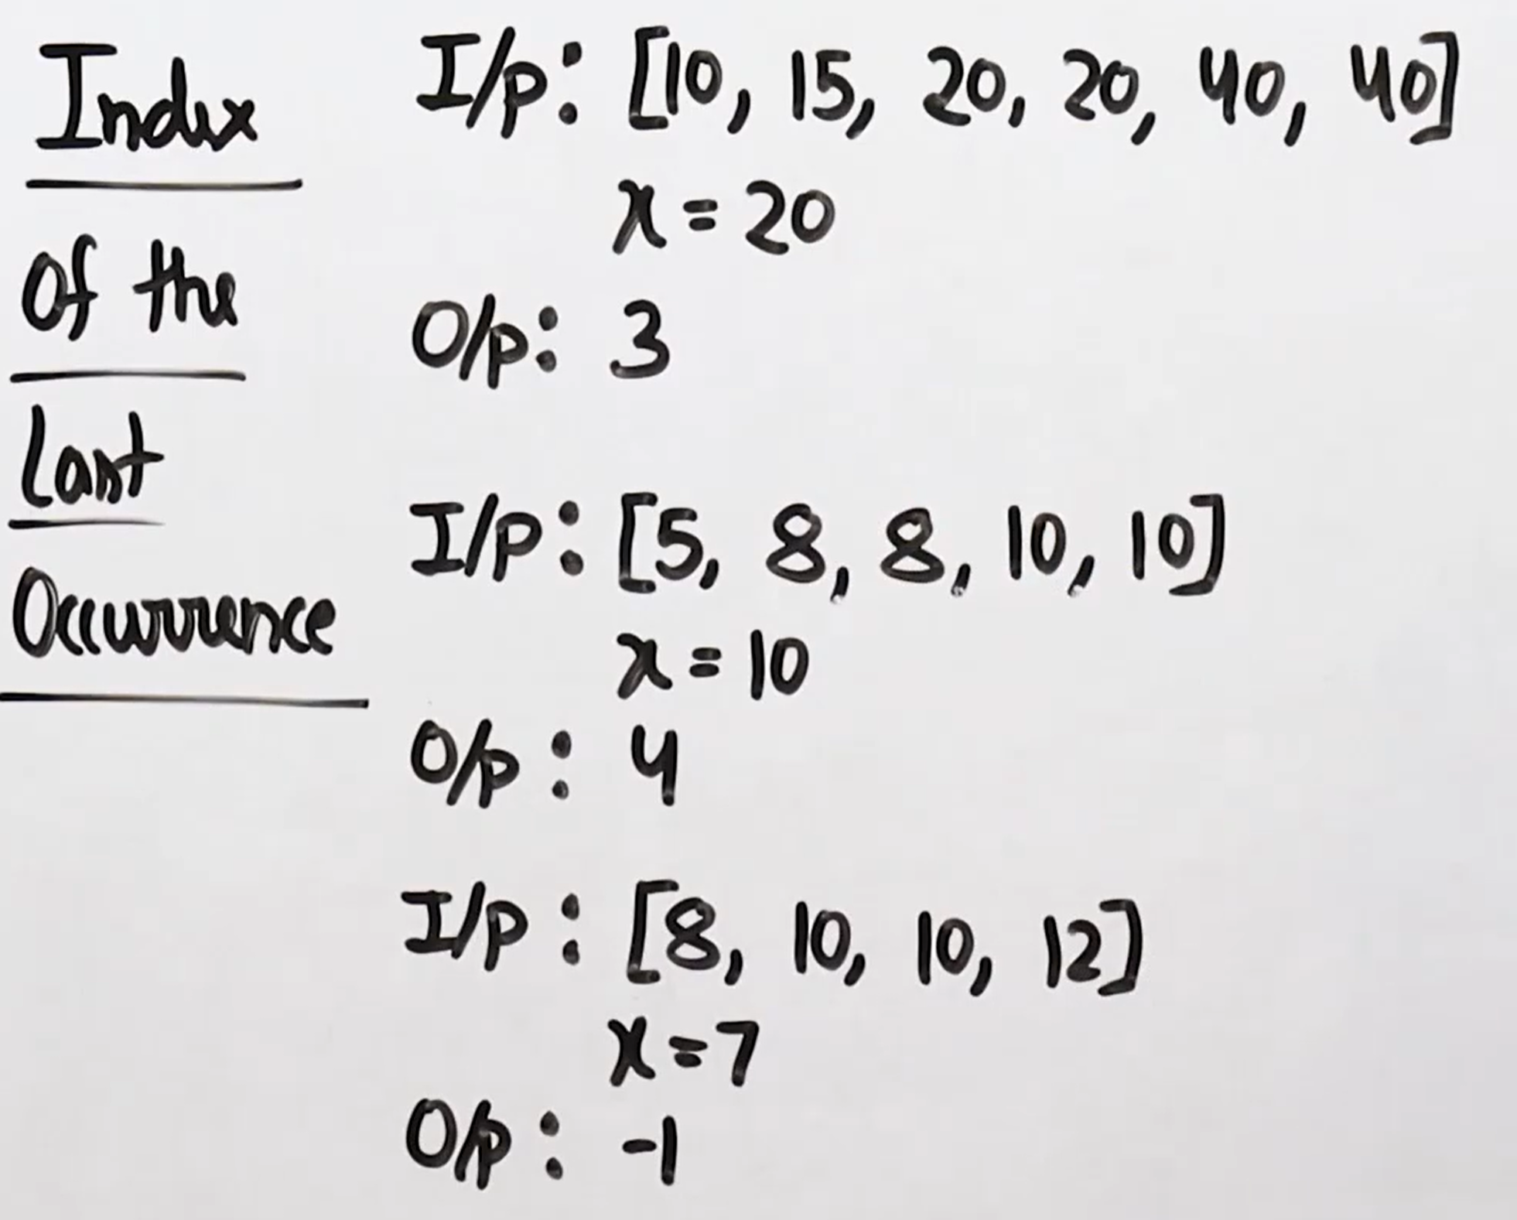
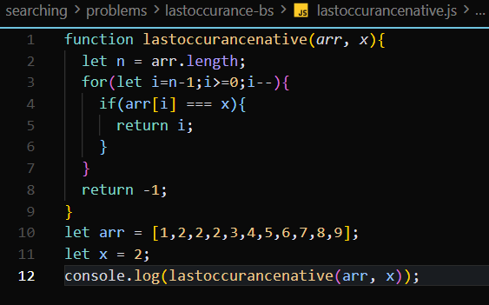
In this code It is the native with the o(n) time complexity.
When we find the element, we are using the binary search, we go through the iteration and then we find the last occurrence of the element.
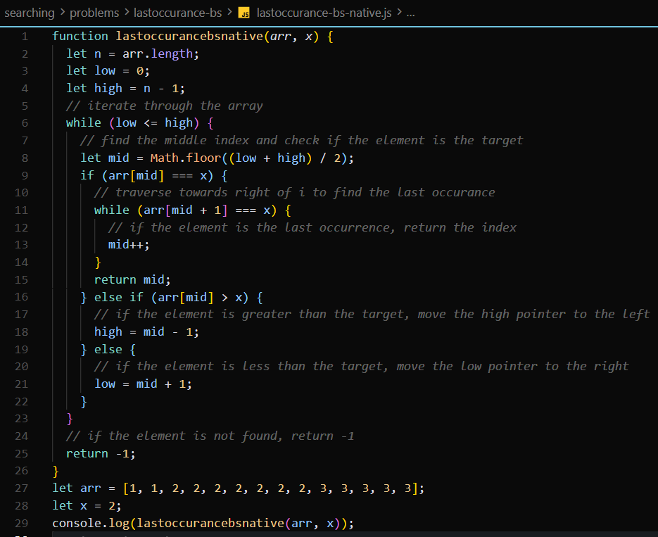
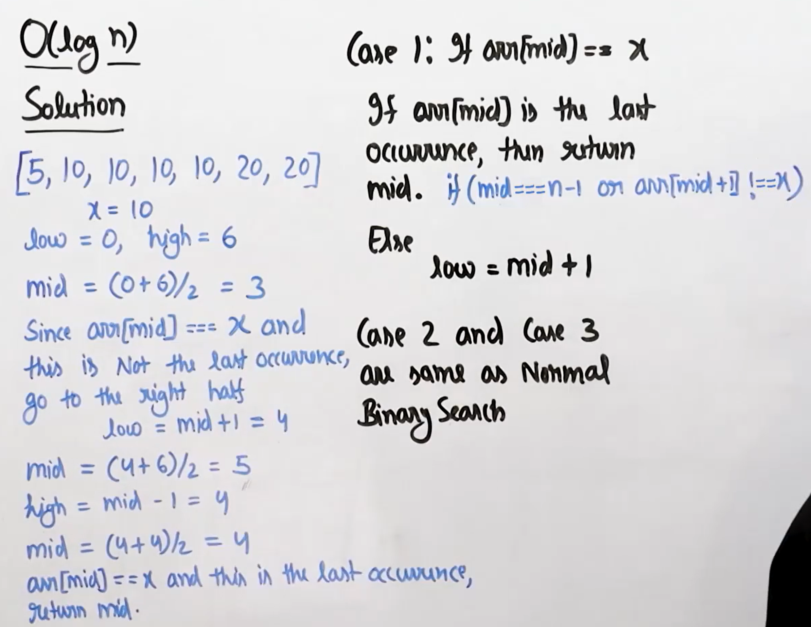
This is the optimal approach by using the binary search and making the code optimal. 

